Bugs & Improvements
Saucedemo Automation Suite Notes
Improvments : Framework
- Testing Framework: Using Page Objects Model: separate the page elements from the test page this way if an element has changed it only needs to be changed in one place (pageobject page) and it will affect all the instances using that element
- Handlin .env file: add .env to .gitgnore to: protect the sensitive date, conform with Playwright expectations, prevent from a CI/CD tools from version control it
- BasePage: use a basepage to store methods that are repetitive (click,getText,fillText etc) in one toolbox for a cleaner code that and keeping the DRY principle
- Add accessability testsuite: adding a test suite that locates the elements using getByRole,getByPlaceholder,getByName that interacts with the Aria roles
Improvments : Usability UX/UI
- Navbar – Logout Button does not prompt an alert to affirm the choice to logout by the user (user can logout by mistake)
- Navbar Fram - the Navbar has no visible frame and the background color is in the exact same color as the pages across the app (when a user opens the Navbar it seems as if the information is missing and not covered by the Navbar layer)
Bugs
Bug #1
Title : Quantity field of purchased items is not clickable and cannot be edited across all pages
Environment: Production
Status: New
Platform: Web (chrome,firefox)
Severity: Medium
Priority: to be determined by product manager
Steps to reproduce:
- Open the website
- Add an item to the cart
- Go to cart page
- On cart page: click on the value of the QTY next to the item (img_1)
- On cart page: click on the checkout button to move to checkout
- On checkout your information page: fill form with valid info and click continue button
- On checkout Overview page: click on the value of the QTY next to the item (img_2)

Expected Results: the value in QTY is of type: input and accepts editing (changing to other int values) enabling the user to order more than 1 Quantity per item
Actual Results: The element is of type Div and does not accept any editing and has no nested input elements as well
Note: images 1 and 2, no Turnaround to bypass this issue
Img_1: Cart Overview page
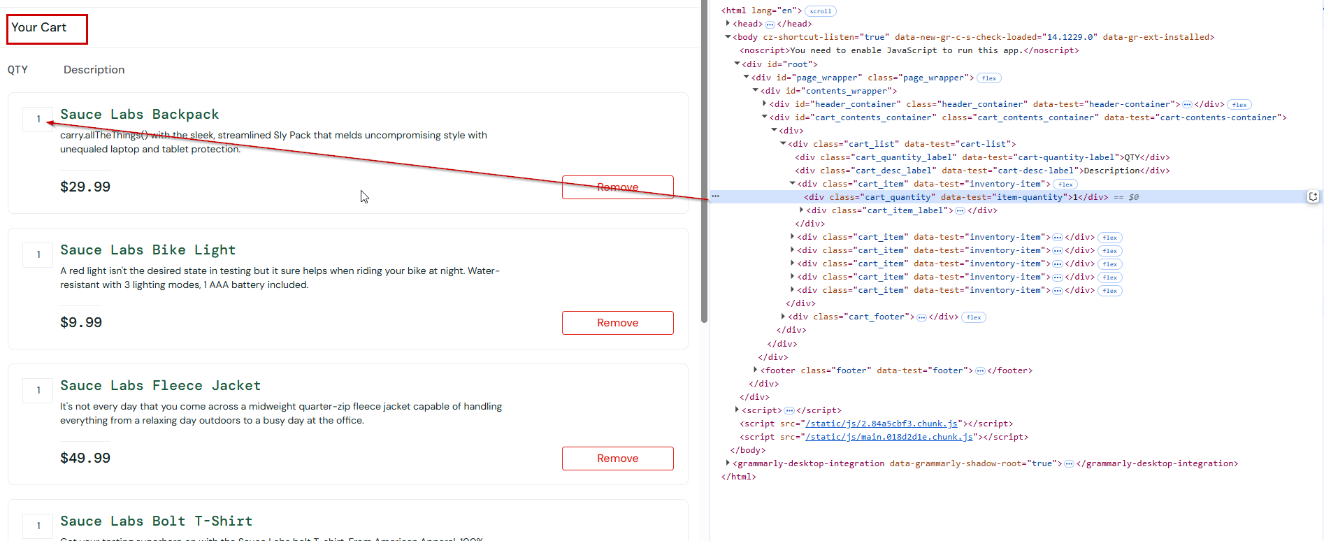

Img_2 : Checkout Overview page
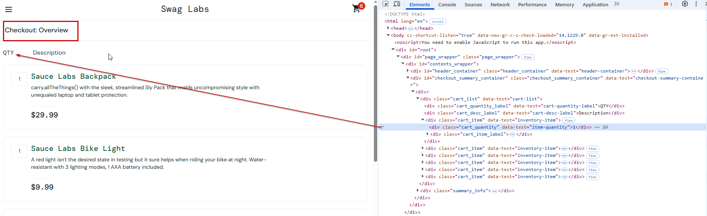
Bug #2
Title : Checkout Overview page – When only one field is filled and the user clicks on the Continue button the validation error contains an alert about one field only
Environment: Production
Status: New
Platform: Web (chrome,firefox)
Severity: LOW
Priority: to be determined by product manager

Steps to reproduce:
- Open the website
- Add an item to the cart
- Go to cart page
- On cart page: click on the checkout button to move to checkout

- On checkout your information page: fill info in 3 ways: each test fills only 2 fields

- 1: First Name: Test | Last Name: | Zip/Postal Code: and click Continue
- 2: First Name: | Last Name: Test| Zip/Postal Code: and click Continue
- 3: First Name: | Last Name: | Zip/Postal Code: 12345 and click Continue

Expected Results: each scenario should display a validation error that includes Both fields that were left empty
Actual Results: each scenario display a validation field error for only 1 field and not 2
Note: images 1, 2, 3
Img 1 scenario 1
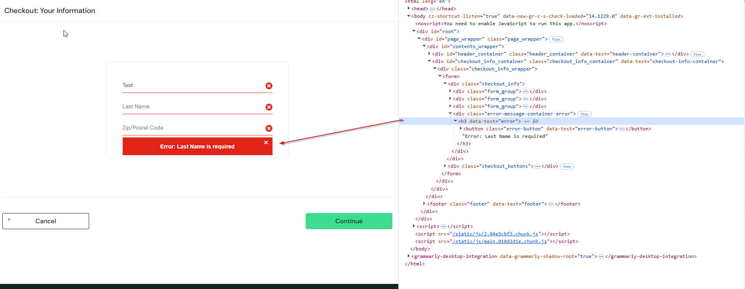
Img 2 scenario 2
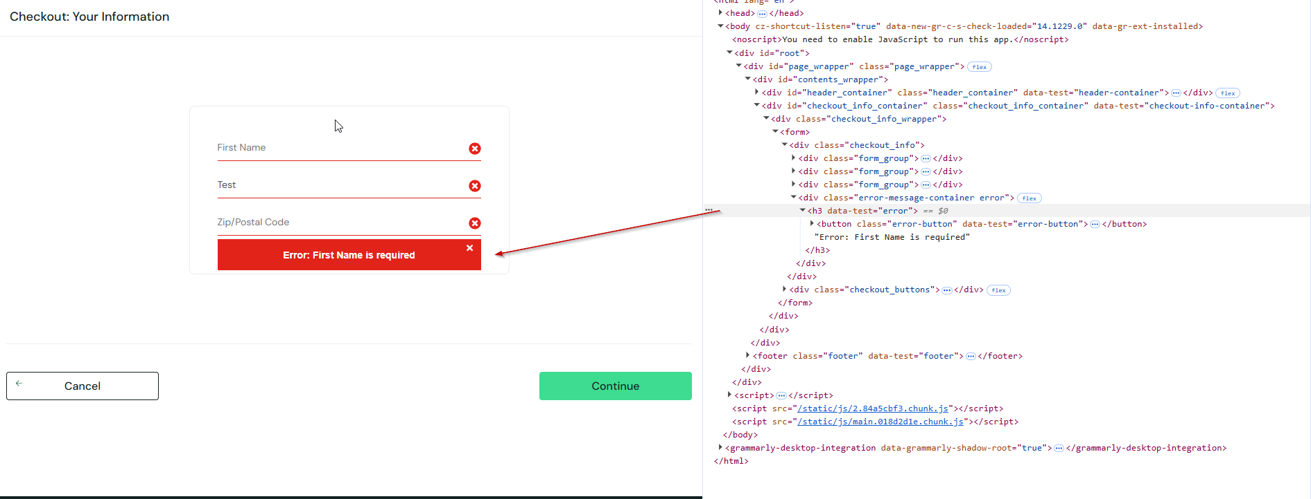
Img 3 scenario 3
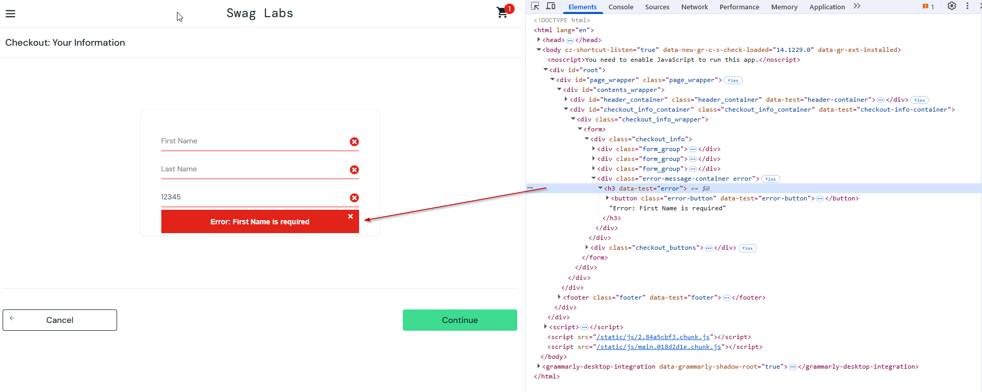
Bug #3
Title : Navbar -Reset Button does not clear the filtering made on Home Page (preset filter remains and does not change to the default value: Name (A to Z) )
Environment: Production
Status: MEDIUM
Platform: Web (chrome,firefox)
Severity: Medium
Priority: to be determined by product manager
Steps to reproduce:
- Open the website
- Verify default value of Filter is: Name (A to Z)
- Filter results By these values: Name (Z to A) , Price (low to high) , Price (high to low)
- Open side bar menu after each choice of a filter
- Click on Reset App State
Expected Results: The filter Resets to its Default state: Name (A to Z)
Actual Results: The filter Does not Reset to the default state and keeps the previous choice
Note: in the Elements tab its is clear that there is not attribute of : Selected in the Option values of the drop down Select element therefore there is not way to flag the signed filter (see img_1 below)
